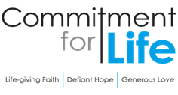
Moving
Stories
ISRAEL & THE OCCUPIED PALESTINIAN TERRITORY
Begin with silence; or use music as a bed for this prayer.

Living God, who clothes us in garments of gratitude, adorn this prayer with the light of your grace. We bring to mind the many blessings that you so generously give…

Moment of silence…

We prayer for those gathered in this place…
those in our churches…
those in our communities…
for those who selflessly serve in making the world a better place.

Forgiving God, we too easily diminish the dignity of others, sowing division when you call for openness and trust.
Lord, have mercy;
Lord, have mercy.

We stand ashamed at the depth to which humanity can sink, how easily we march to the drums of war, how quickly we are swayed and seduced by the savagery of self-justifying narratives.
Christ, have mercy;
Christ, have mercy.

May the Trinity of Love bind our wounds, challenge our complacency, bring freedom from oppression, and lead all to abundance of freedom.

Amen.

Since 7 October, the Israeli occupational forces have taken (at the time of writing) almost 28,000 Palestinian lives in Gaza. 12,000 of them were children. About 67,000 Gazans have been injured. Over 8,000 people are missing or buried beneath rubble. More than half of Gaza’s homes have been damaged or destroyed, along with 368 schools or colleges and 221 places of worship. In addition, almost 400 Palestinians have been killed in the West Bank, over a quarter of them children.
Photo: by Health Ministry in Gaza, UNOCHA
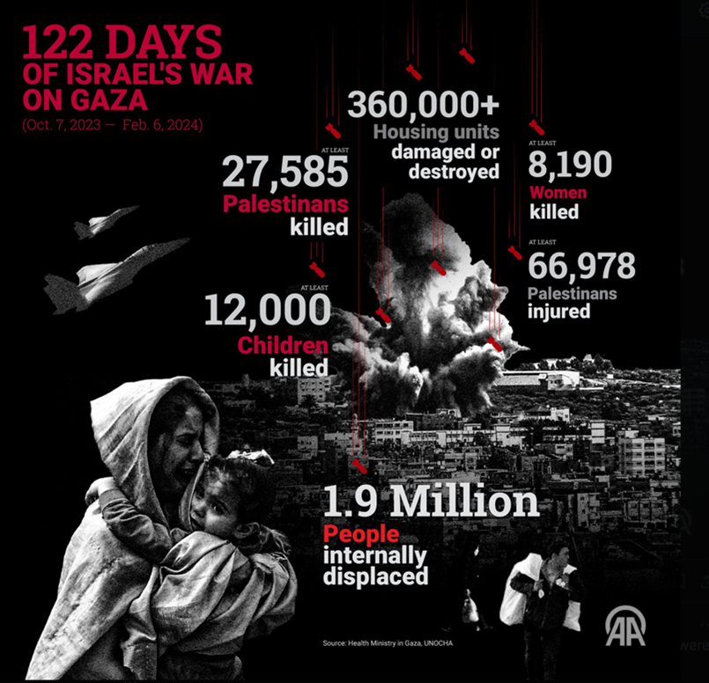
On 26 January, the International Court of Justice in the Hague ruled that at least some of the acts "committed by Israel in Gaza appear to be capable of falling within the provisions of the Genocide Convention". Yet the US and UK continue to arm Israel. They have also attempted to defund UNWRA based on unproven allegations of UN workers’ involvement in the 7 October attack. At the same time, over 1,200 people in Israel have been killed, 9,000 injured.
Commitment for Life shares its deep sorrow in the face of this appalling, unfolding genocide. We believe in the inherent goodness, mercy and humanity of Israelis and Palestinians. Love ultimately wins.
We are determined to continue our support for our partners in Gaza such as the Culture and Free Thought Association (CFTA). CFTA runs four youth centres in Khan Younis in southern Gaza. These are places where young people learn leadership skills and coping mechanisms in the face of occupation and violence.
Thank you for your continued support for this amazing project through your partnership with Commitment for Life and Christian Aid.

