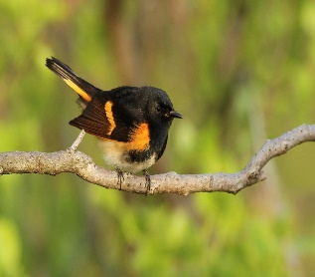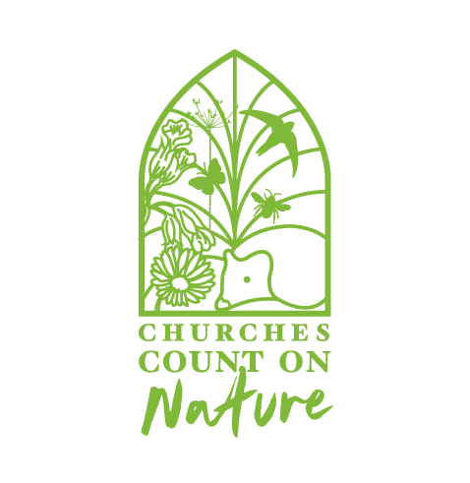
This Photo by Unknown Author is licensed under CC BY

CHURCHES COUNT ON NATURE 5TH JUNE – 13TH JUNE 2021

CHRIST CHURCH URC PETTS WOOD

COME AND SPOT, IDENTIFY AND RECORD THE
WILDLIFE IN THE CHURCH GARDEN
ALL WELOCOME

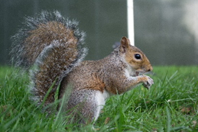

TO TAKE PART AND FOR FULL DETAILS CONTACT:
DAVID WATTS – yamseng2@yahoo.co.uk
This Photo by Unknown Author is licensed under CC BY

