Sunday 12th July 2020

CHRIST CHURCH PETTS WOOD
Church banking

Sort Code
23-05-80

Account
22302684
Contact & Care sheet
to help you stay connected to Christ Church during these challenging times. Please email fionafogden@hotmail.com or call 01689 605563 for any contributions to the newsletter

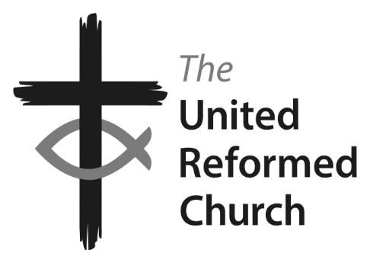

Minister: the Revd Nadene Snyman – The Minister’s day off is Saturday
Tel: 01689 637625 or 0787 670 7863 email: nadene72@gmail.com.
Facebook: Find us at ccpwurc Website: https://christchurchpettswood.org.uk
Church Secretary: Kat Copley kat@copley.online 07729 215674
Pastoral Care: Elsa Duce 01689 822764
Donate: https://christchurchpettswood.org.uk/about-us-2/supporting-christ-church/
Service on Sunday 12th July

Christ Church service led by Our Minister on the theme of Parables
Hymns : Take my life
You shall go out with joy

Readings: Matthew 13: 1-9 and 18-23
Isaiah 55: 10-13

The service will be via YouTube so please dial in using 020 7023 2760
Code: 116 2567#
Hymn Sheet

Take my life
1 Take my life, and let it be
consecrated, Lord, to thee;
Take my moments and my days;
let them flow in endless praise.
2 Take my hands and let them move
at the impulse of thy love.
Take my feet and let them be
swift and beautiful for thee.
3 Take my voice and let me sing
always, only, for my King.
Take my lips and let them be,
filled with messages from thee.
4 Take my silver and my gold;
not a mite would I withhold.
Take my intellect and use
every power as thou shalt choose.
5 Take my will and make it thine;
it shall be no longer mine.
Take my heart it is thine own;
it shall be thy royal throne.
6 Take my love; my Lord, I pour
at thy feet its treasure store.
Take myself, and I will be
ever, only, all for thee.

You shall go out with joy

You shall go out with joy
And be let forth with peace,
And the mountains and the hills
Shall break forth before you.
There'll be shouts of joy
And the trees of the fields
Shall clap, shall clap their hands.

And the trees of the fields shall clap their hands,
And the trees of the fields shall clap their hands,
And the trees of the fields shall clap their hands,
And you'll go out with joy.
CCL 114720
A letter from our Minister

Dearest Christ Church,

We had a very positive and successful Elder's meeting on Wednesday. There was a lovely atmosphere in the meeting and a real solidarity between us all. I would also like to thank everyone for their prayers. We felt them lifting us up.

We had a number of big decisions to make which I would like to share with you.

Firstly, on the issue of Private Prayer we have decided to start opening for prayer in the first week of August. We will open on Mondays 11am - 2pm and Thursdays 7-9pm. We will be producing a video explaining how this silent Private Prayer will work and the procedures of accessing the building safely. This video will be sent around to everyone and for those not on YouTube we will send out detailed instructions.

Secondly, the majority felt that we are not ready to open up for Sunday worship. We have not yet received detailed guidance from the URC as to how to proceed safely. We have therefore made the decision to relook at opening for worship at the September 9th Elder's meeting. At that meeting we will reassess the updated government guidance and the URC's advice.

Thirdly, we have an Church Meeting on the 19th of July (details to follow) where we will ask you all to participate in decisions regarding the renovation of the kitchen (and upgrading electrics with that) as well as a new project to install Audio Visual equipment in the church to stream all future services to YouTube and Facebook.

Fourthly, we will be seeking guidance as to how to start up some social distancing group meet ups for socialising on the church grounds, so spend time together connecting in a safe way.

And finally, we are going to begin to plan online socials e.g. A Zoom Bingo Evening for the whole family.

We therefore look forward to silent prayer together as well as moving forward on future mission projects and embracing the current opportunities to do things a little differently.

Sending you all my love and prayers at this time

Blessings,

Rev Nadene Snyman
Christ Church URC (Petts Wood) and Beckenham URC

Diary of events
Date | Time | Description
Weds 8th July | 12.30pm | Lunch club deliveries
Friday 10th | 10.30am | Coffee Stop
Sunday 12th July | 10.30am | Sunday service via YouTube and dial-in
Tuesday 14th July | 7.45pm | Solace (via Zoom or YouTube)
Weds 15th July | 12.30pm | Lunch club deliveries
Friday 17th July | 10.30am | Coffee Stop
Sunday 19th July | 11.30am | Church meeting after the  church service
Monday 3rd August | 11am-2pm | Church open for Private Prayer
Thurs 6th August | 7pm-9pm | Church open for Private Prayer

