Contact & Care sheet
to help you stay connected to Christ Church during these challenging times
CHRIST CHURCH PETTS WOOD

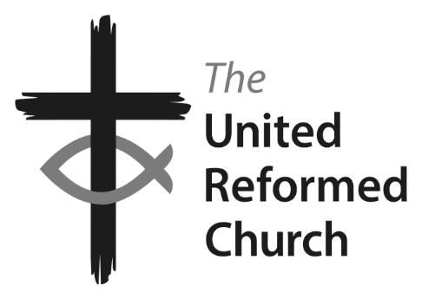

Minister: the Revd Nadene Snyman
Tel: 01689 637625 or 0787 670 7863 email: nadene72@gmail.com
Minister’s day off is Saturday
Facebook: Find us at ccpwurc Website: https://christchurchpettswood.org.uk
Church Secretary: Kat Copley kat@copley.online 07729 215674
Pastoral Care: Elsa Duce 01689 822764
On the enclosed audio CD you will hear:

- Bible reading: 1 Samuel 16, v1-13 and John 9:1-12
- Hymn: Be thou my vision (words to the right)
- Sermon on the theme of Refocussing on God in times of change
Others will be watching this on YouTube at around 10.30am on Sunday 22nd March and we invite you to listen at the same time to feel connected to Christ Church, even though we might be apart.
Be thou my vision, O Lord of my heart;
Naught be all else to me, save that thou art -
Thou my best thought, by day or by night;
Waking or sleeping, thy presence my light.

Be thou my wisdom, and thou my true word;
I ever with thee and thou with me, Lord.
Thou my great Father; thine own may I be,
Thou in me dwelling and I one with thee.

Be thou my breastplate, my sword for the fight;
Be thou my dignity, thou my delight,
Thou my soul’s shelter, and thou my strong tower;
Raise thou me heave’nward, great Power of my power

Riches I heed not, nor vain, empty praise;
Thou mine inheritance, now and always;
Thou and thou only first in my heart,
High King of heaven, my treasure thou art.

High King of heaven, my victory won,
May I reach heaven's joys, O bright heaven's sun!
Heart of my own heart, whatever befall,
Still be my vision, O Ruler of all. CCL 114720

CHURCH OPEN FOR PRIVATE PRAYER

Monday 11am-2pm
Thursday 7pm-9pm

You may come and go quietly as you please during this time. As per Government guidance, please keep your distance from others.

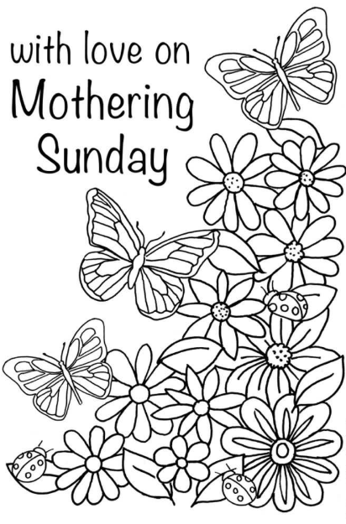

A letter from our Minister

Hello Christ Church URC,

We have been advised by the URC to close down worship services, church activities and physical meetings as a response to the government's guidance.

Therefore, until further notice this will be the case.

Obviously, this is a difficult time for us all and we want to continue to worship, communicate and support one another through these strange and challenging times.

We will therefore be putting a number of things in place:
- You will all receive a personal phone call, as not everyone is on email, we will use our telephone tree throughout this time of isolation to keep a check on one another
- I will offer weekly acts of worship through a YouTube clip which you will be sent the link to on Sunday morning. All you will need to do is click on the link to watch the clip. For those who are not on email we will deliver a CD with the worship on that they will be able to listen to on a CD player. We are aware of those folks in our congregation who will need a CD
- I will notify you of when the church will be open for times of personal prayer - we will ask you to please wash your hands in the bathrooms at the entrance of the church and on entry to the church to use hand sanitiser. Also please stay a safe distance away from one another
- We have a prayer WhatsApp group that Kerry McMenamin in running and please do join it. Text Kerry your name and number and she will add you to the group 07740365100. We pray each night at 9pm 'together'
- The URC has a daily devotions that you can sign up to and from this weekend they will be providing a Sunday act of worship as well, you can sign up with this link if you have not already devotions.urc.org.uk
- There are a number of people in the church who have offered to get groceries, medication and odd jobs for folks who need the help, so please contact Kat, Fiona or myself and let us know what you need and we will co-ordinate our volunteers
Please be assured that we will all get through this tough period together. We will be able to worship together in different ways but God is with us no matter what form this worship takes. It is potentially an exciting opportunity to find new ways to worship together, to communicate differently and to support one another.

Please be assured of my love and prayers and please do be in touch with what ever you need over the coming weeks.

Blessings,

Rev Nadene Snyman
Christ Church URC (Petts Wood) and Beckenham URC
07876707863 / 01689 637625

