Contact & Care sheet
to help you stay connected to Christ Church during these challenging times
CHRIST CHURCH PETTS WOOD

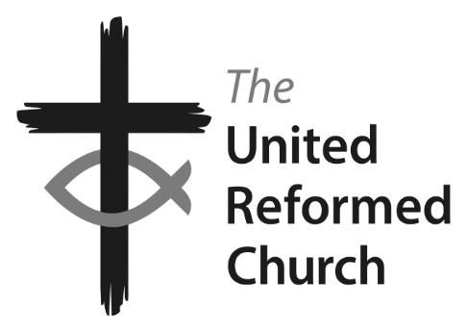

Minister: the Revd Nadene Snyman
Tel: 01689 637625 or 0787 670 7863 email: nadene72@gmail.com
Minister’s day off is Saturday
Facebook: Find us at ccpwurc Website: https://christchurchpettswood.org.uk
Church Secretary: Kat Copley kat@copley.online 07729 215674
Pastoral Care: Elsa Duce 01689 822764
On the video you will hear:

- Bible reading: Ezekiel 37: 1-14 and John 11: 1-45
- Hymn: Breathe on me, breath of God (words to the right)
- Sermon on the theme of New Life in these troubled times
Others will be watching this on YouTube or dialling in via an audio call at around 10.30am on Sunday 29th March and we invite you to listen at the same time to feel connected to Christ Church, even though we might be apart.
1 Breathe on me, breath of God:
fill me with life anew,
that I may love what thou dost love
and do as you wouldst do.
2 Breathe on me, breath of God;
till I am wholly thine,
until this earthly part of me
glows with thy fire divine.
3 Breathe on me, breath of God;
so shall I never die,
but live with thee the perfect life
of thine eternity.
CCL 114720

Let’s give thanks
- For the workers in our NHS
- The Christ Church & Beckenham communities and our Minister Nadene
- The innovation and technology that keeps us connected, the hands of love for those that are not digitally capable
- The kindness that abounds in times of trouble

Prayer

Whilst we are unable to meet for prayer, we are joining
together in different ways to pray.
To join our WhatsApp group please contact Kerry on 07740 365100. If you do not have WhatsApp, but do have email please email contact fionafogden@hotmail.com who will send you the summary for the day each evening. Anyone can call 01689 605563 and ask for a prayer to be said or shared to the group.

A letter from our Treasurer

Dear Christ Church family,

I know you will probably be concerned about our financial health at this time.

I will be looking at our lost revenue over the coming weeks to give a possible projection on our surplus/loss at the end of the Financial Year.

Just to summarise we will not be getting income from our lettings. Those that give donations via FWO (Free Will Offering) envelopes or loose collections will not be able to donate these at present.

For those with FWO envelopes you have the following options:
- Please hold onto them and when we are able to open the Church again bring them with you on the first Sunday you attend.
For those that donate via loose collections. You have three options for making a donation. This can be
- via our donations link to VirginMoneyGiving on our website: https://christchurchpettswood.org.uk/about-us-2/supporting-christ-church/
- a BACS payment direct into the account (sort code: 230580 account number: 22302684)
- keep hold of it and, like the envelopes, bring it with you when you are next in Church

I will keep you up to date with the state of our accounts as the country goes through this crisis.

Finally, to help us understand the impact on the Church finances we would appreciate, in confidence, any indication of sums you might be holding on to. Similarly, if your financial situation has changed and you don't feel you can continue to offer the same amount, please let us know - so we can best plan for the future.

For those that give via envelopes can you please let Stephen McNamara know as Gift Aid secretary and he can let me know the figures.

A huge thank you for continuing to support the church whether financially, practically or emotionally at this challenging time.

Any question please do not hesitate to contact me.

Martin

