19th April 2020

**Contact & Care sheet**   
to help you stay connected to Christ Church during these challenging times. Please email [fionafogden@hotmail.com](mailto:fionafogden@hotmail.com) or call 01689 605563 for any contributions

**CHRIST CHURCH PETTS WOOD**

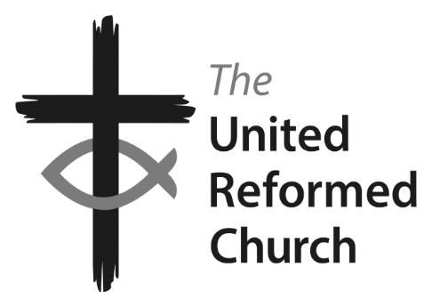

Minister: the Revd Nadene Snyman

Tel: 01689 637625 or 0787 670 7863 email: [nadene72@gmail.com](mailto:nadene72@gmail.com)

Minister’s day off is Saturday

Facebook: Find us at ccpwurc Website: https://christchurchpettswood.org.uk

Church Secretary: Kat Copley [kat@copley.online](mailto:kat@copley.online) 07729 215674

Pastoral Care: Elsa Duce 01689 822764



For the healing of the nations,

Lord, we pray with one accord,

for a just and equal sharing

of the things that earth affords.

To a life of love in action

help us rise and pledge our word.

Lead us forward into freedom,

from despair your world release,

that, redeemed from war and hatred,

all may come and go in peace.

Show us how through care and goodness

fear will die and hope increase.

All that kills abundant living,

let it from the earth be banned:

pride of status, race or schooling,

dogmas that obscure your plan.

In our common quest for justice

may we hallow brief life's span.

You, Creator God, have written

your great name on humankind;

for our growing in your likeness

bring the life of Christ to mind;

that by our response and service

earth its destiny may find. CCL 114720

**On the video you will hear:**

* Readings: Luke 4: 14 - 19
* Hymn: For the healing of the nations (words to the right)
* Service on the theme of Commitment for Life with special reference to Israel and the occupied Palestinian territories.

Others will be watching this on YouTube or dialling in via an audio call at around 10.30am on **Sunday 19th April** and we invite you to listen at the same time to feel connected to Christ Church, even though we might be apart.

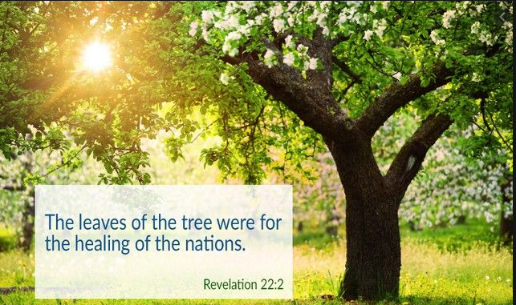

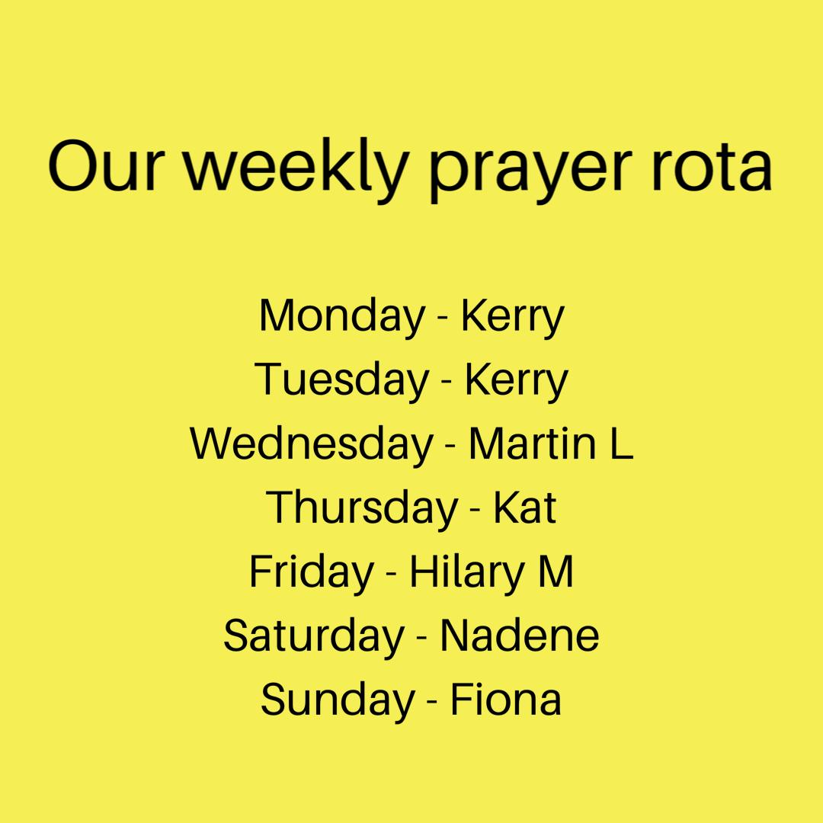

**Prayers**

Prayers at 9pm every evening via WhatsApp will be continuing but we would like to celebrate a month of this special prayer group. Thank you Kerry!!!! Going forward Kerry will still be starting off the prayers two evenings but we now have a new prayer rota with others helping the rest of the week. Go team!

**Forthcoming events**

**Weekly – Solace online –** See<https://christchurchpettswood.org.uk/solace/>for audio services

**Fridays from 10.30am – Coffee Stop**. Coffee Stop has moved to Zoom! Link will be shared via the WhatsApp group or via email.

**Lunch club – Wednesdays** – Linda, Alison and the delivery volunteers do their magic and deliver an amazing meal (and pudding!) to many of our lunch club members.

**Sunday service** **@10.30am** – this is happening via a combination of Zoom, YouTube or conference call.

**Prayers - Every night at 9pm** – We have our WhatsApp prayer group. Those not on WhatsApp but email can get the messages of the day emailed, please contact Fiona if you want to be included.

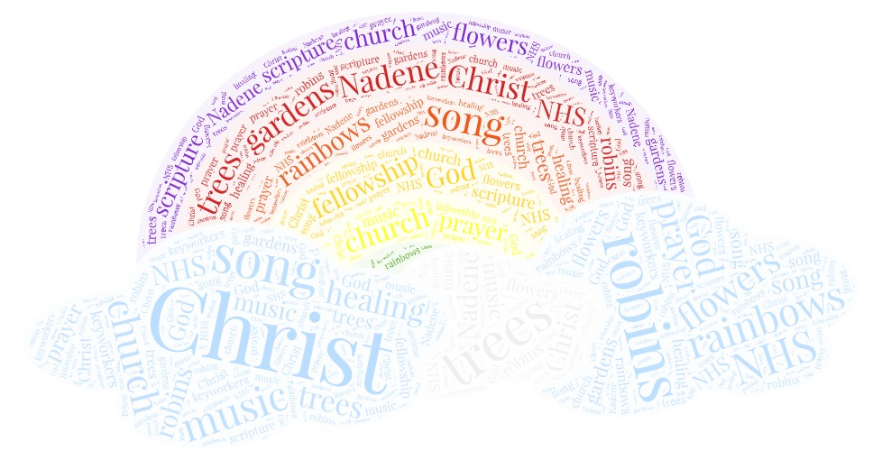

**We give thanks for…**

**Birthdays this week**

* Jack Fosten has a birthday today (Sunday)
* Jack Wolfe & Chanpen Powell have a birthday on Tuesday
* Janet Downes on Wednesday
* Peter Dale on Friday
* Pat Crowther on Saturday

The Leprosy Mission has sent us the following note:

Many thanks to all who so generously donated to the Leprosy Mission at the Service in February. The sum of £301.03 was raised and Jarett has asked me to pass on his thanks for the warm welcome which he was given (Carole Scoular

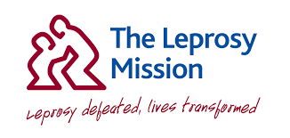

**Leprosy Mission and Commitment for Life**



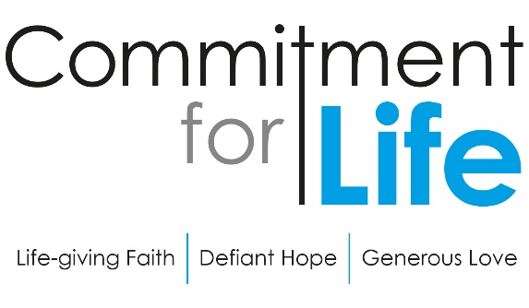

**Medical Trauma in Gaza**

Quarantine affects us all, but the movement of people and goods into Gaza have been severely restricted for over a decade.

Three-year old Jana from Jabalia has cancer. Due to the size of her tumour, Jana needs radiotherapy treatment that isn’t available in Gaza. Doctors lack the medication and necessary equipment to treat the children of Gaza. Every single case of cancer children or adults requires the referral outside the Gaza Strip.

Obtaining travel permits for medical therapy in Jerusalem is a bureaucratic ordeal. The situation is further complicated when the patient is a child in need for parental physical emotional support as parents are often denied permission to travel.

In solidarity with Christian Aid partner The Lutheran World Federation, we call on Israel, as the occupying power and duty bearer under International Law, to

* respect the  rights of the child and their right to health
* ensure that all children diagnosed with cancer from the Gaza Strip should immediately be treated without delay
* once diagnosed with cancer the child must be given a permit for an initial period of one year for active treatment and appropriate follow up without the child having to go through the same permit process every time, and risk missing appointments in hospitals
* allow children referred for medical treatment outside Gaza should be accompanied by at least one parent.

We ask all *Commitment for Life* supporters to pray for these concerns, particularly on the 24th of each month. Further information on these prayers can be found here: <http://actpalestineforum.org>

**Moving Stories**

**Israel and   
the occupied Palestinian territories**

**A letter from Bromley Foodbank**

Dear Foodbank Supporters,

The foodbank is under extreme strain at this very challenging time, with more people than ever needing help. Many wonderful supporters are constantly getting in touch with queries as to how they might help. Unfortunately, this means that the Project Manager receives over 200 incoming emails, phone calls and other messaging per day! There aren't enough hours in the day to answer them. Therefore, **please try to limit correspondence.**

I often find that the answers to the questions people ask me are to be found on the website:

<https://bromleyborough.foodbank.org.uk/>

There is also a Bromley Borough Foodbank Facebook page.

If you have urgent queries, please ask me and I'll try to help.

**1) It is going to be necessary to close the warehouse for donations** as Foodbank closes all the centres within the Borough and changes over to a delivery service during this Covid19 pandemic, starting Monday 20th April.

However, **donations can now be taken to Oak Community Church, 345 Chipperfield Road, St. Paul's Cray, BR5 2LJ on Mondays and Thursdays 10am -12 noon.**

Shoppers can continue to use the supermarket collection points.

**These are currently the most needed items:**

Tinned potatoes (desperately needed!)

Baked beans

Squash

Tinned fruit

Custard

Rice pudding

Pulses

The following are **not needed**:

Tomatoes

Soup

Vegetables

Coffee

Fish

**2) Details of how to donate financially are on the website.**There is a link to 'Now Donate' if you wish to donate online, using Pay Pal or a credit card. Alternatively, cheque or cash donations should be sent:

 c/o Orpington Baptist Church, Station Road, Orpington, BR6 0RZ.

**3) Volunteering.** The foodbank has enough volunteers for the time being. **If you have past referral experience in connection with the foodbank your help is likely to be much needed to man telephones.**

**If you would like to help in other ways after the current Covid 19 crisis,**please let me know or email directly to [volunteers@bromleyborough.foodbank.org.uk](mailto:volunteers@bromleyborough.foodbank.org.uk)

A sincere thank on behalf of Bromley Borough Foodbank,

Vanessa Dixon

Foodbank Volunteer